In order to apply for participating in SSA activities, please send the filled and signed application form for SSA
activity to Anikó Hollander (1-3. Szepesy I. street, 7621 Pécs) until 2 April 2023.
APPLICATION FORM FOR STUDENTS’ SCIENTIFIC ASSOCIATION ACTIVITY
–
to be filled in by the student!
Name of student:
Study programme:
NEPTUN code:
Form of education:
Year.:
Group:
Student’s GPA (Grade Point Average of the last two semesters):
I. semester:
II. semester:
language
Language exam:
level
level
type
type
language
Title of SSA project:
Supervisor(s) name, institution and telephone number
1
2
3
The above-mentioned student is accepted as my SSA student in the given topic.
Date:
.
.…………………..
Supervisor(s)
…………………….
Supervisor(s)
……………………..
Supervisor(s)
……………………………………………..
Head of Institute / Head of Department
The application is only valid with the signatures of the supervisors and the Head of Institute / Head of Department!
To be filled in by the Registrar’s Office of the Training Center
The above-mentioned student’s personal data are corresponding with the database.
…
……………………….
Date
stamp
administrator of registrar
To be filled in by the Registrar’s Office in Pécs!
Registration number: ………….
…
……………………….
Date
stamp
Head of Registrar’s Office
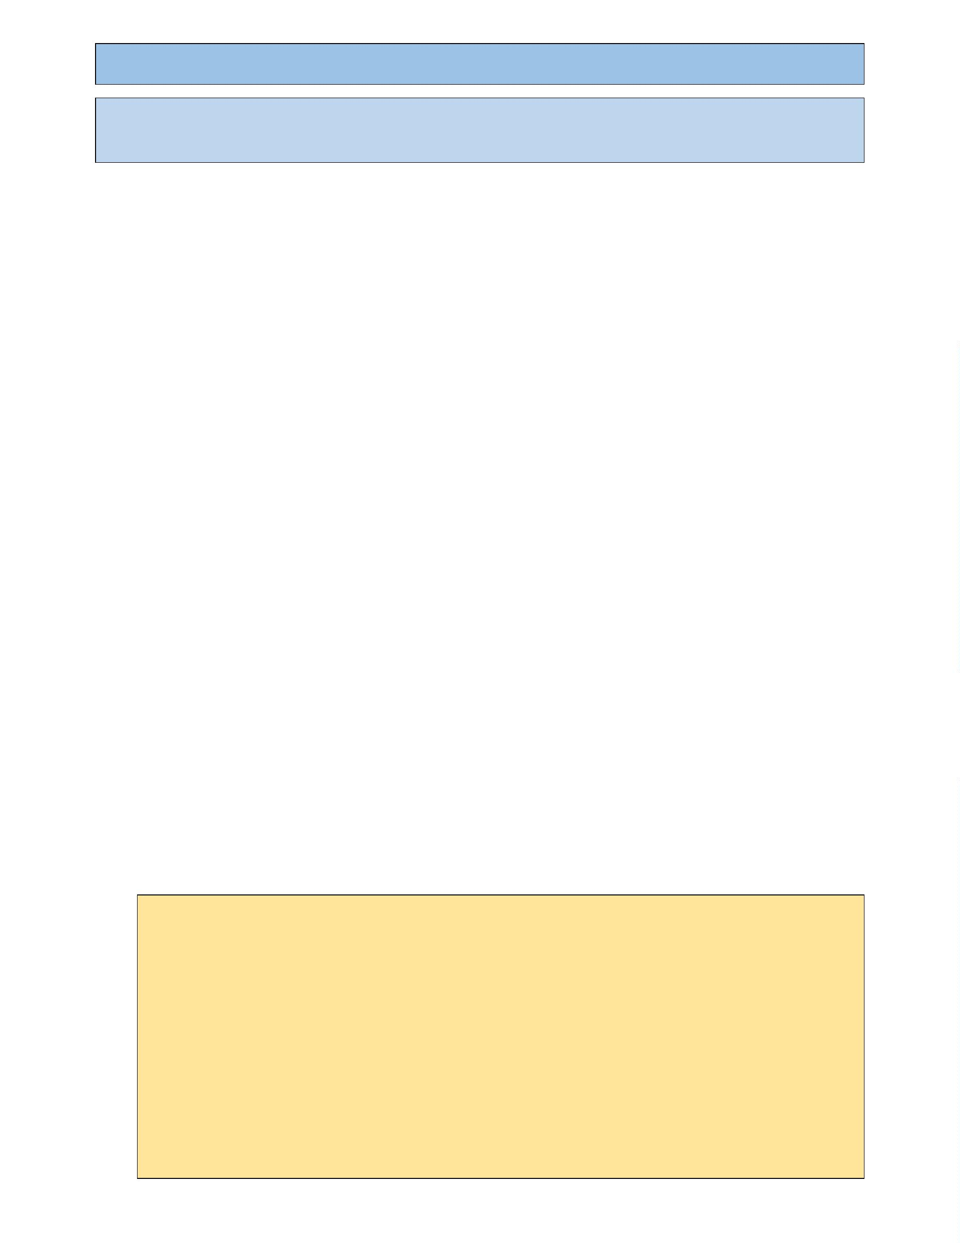

CURRICULUM VITAE – to be filled in by the student
Personal Data:
Name:
Place, date of birth:
Address:
Telephone:
School qualifications:
Further trainings:
IT skills:
Professionalactivities:
Public activities:
Fields of Interest:
Plans, goals:

RESEARCH PLAN OF THE ACTIVITY FOR THE STUDENTS’ SCIENTIFIC
ASSOCIATION – to be filled in by the student
Title of SSA topic:
Name of student:
Name of Supervisor(s):
Introduction of the Research Problem:
Objectives of Research:
Characteristics of Research material/Patients/Sample:
Research method/procedure:
Applied methods:
A report must be submitted every semester by the students to the Head of the Scientific Students’ Association
about their professional development in the Association (1-2 typed pages signed by the supervisor).

